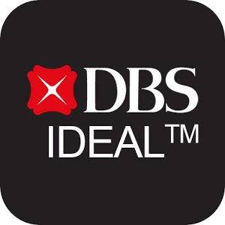 | Training Registration Form

Thank you for choosing DBS IDEAL™ for your online banking needs. To help you get started on DBS IDEAL™, we are pleased to invite you to attend our in-house training program. This program is specially designed to give you an understanding of how to use DBS IDEAL™ to your benefit.

Topics to be Covered (Tick where applicable)

☐ Enquiry

View account statements, trade transactions, remittance advices, subscribe to alerts & trade notifications or enquire on Fixed Deposits.

☐ Payment
Make payments locally & internationally via Bill Payment, Intra Company Transfer, Account Transfer, Bank Cheques, GIRO, MEPS, FAST Payments/Collections or Telegraphic Transfer.
Pls indicate: All payment type OR Specific payment type entered below:

All Payment OR _________________________________________________________________________________

☐ Payroll

Make payroll transfers to multiple recipients on a regular basis via GIRO Payroll.

☐ Collection

Collect payments from customers via GIRO Collection

☐ Trade
Enquire on trade transaction details and history. Send new trade applications relating to Documentary Credit, Documentary Collection, Guarantees & Standby LCs, and Trade Loans; provide acceptance of Import Bills and settlement instructions

Note: This module will be covered only on 26 Mar, 18 Jun, 24 Sep and 17 Dec 2020.

Preferred Training Session – Fill the training date (refer to the next page for the schedule)

☐ AM 9am – 1pm dd/mmm | ☐ PM 2pm – 6pm dd/mmm

Contact Details

Company Name
Participant Name | Participant Mobile Number | Participant Email

Training Registration Form

For registration, please email the completed registration form to idealtraining@dbs.com* two weeks before your desired training date. Our customer service officer will notify you on the confirmed training date via email. The availability of training session is based on a first-come-first-serve basis.

2020 Classroom Training Schedule:
Time | Jan | Feb | Mar | Apr | May | Jun | Jul | Aug | Sep | Oct | Nov | Dec
AM | 14 | 18 | 10 | 7 | 5 | 2 | 7 | 4 | 1 | 6 | 3 | 1
PM | 23 | 27 | 19 | 16 | 14 | 11 | 16 | 13 | 10 | 15 | 12 | 10
PM (with trade) |  |  | 26 |  |  | 18 |  |  | 24 |  |  | 17

Please contact our BusinessCare hotline at 1800-222-2200 (Mondays to Fridays – 8.30am to 8.30pm, except Public Holidays) for further assistance regarding DBS IDEAL.

*This email is strictly for DBS IDEAL™ Training Registration Matters only

Classroom Training Venue: Kaplan Wilkie Edge Campus

Address: Kaplan Wilkie Edge Campus 8 Wilkie Road Level 2 Singapore 228095

Pls refer to the attached pdf for direction:

